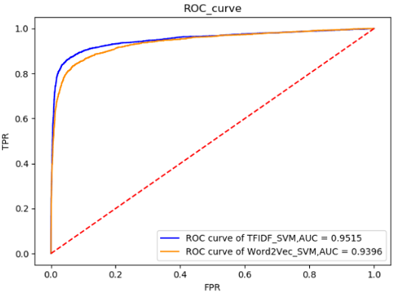 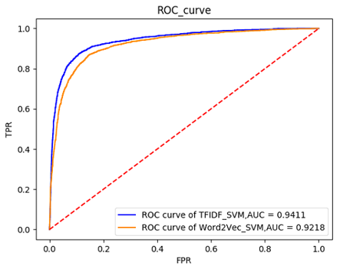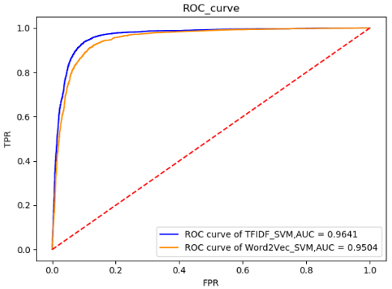

（c）

（b）

（a）

Fig1. The ROC curves of the TF-IDF and word2vec comparison experiment: (a) results for P elements, (b) results for I elements, and (c) results for O elements.

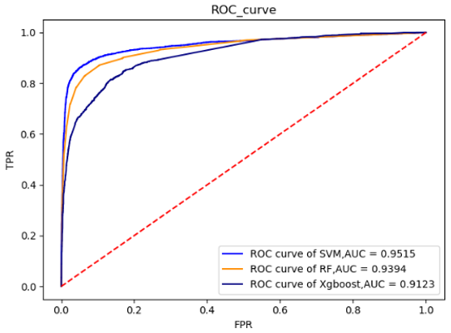 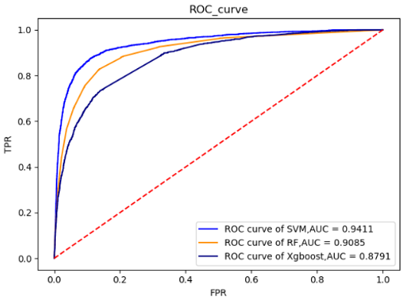 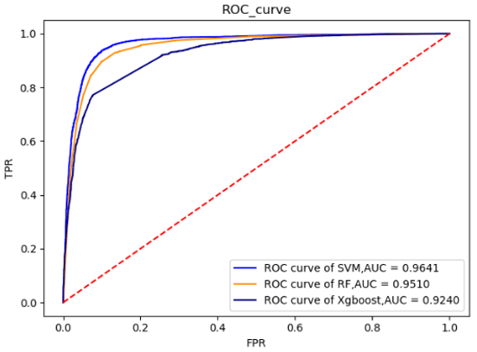

（c）

（b）

（a）

Fig 2: The ROC curves of the SVM model, RF and Xgboost comparison experiment: (a) results for P elements, (b) results for I elements, and (c) results for O elements.

Fig 3: Histograms comparing the experimental results of the SVM model presented in this study, the LSTM model proposed by Di Jin 2018, and the NB model proposed by Ke-Chun Huang 2011: (a) results for P elements, (b) results for I elements, and (c) results for O elements. The three evaluation indicators, i.e., the P, R and F1 values, are represented on the horizontal axes.

Fig 4: Comparative experiment of the penalty parameter C in SVM model. We found that for P and I elements, the model achieved the best F1 values with C=1.0, whereas for O elements, the model achieved the best F1 value with C=0.6.